,_..--..

ORDINANCE NO. 31

AN ORDINANCE DEFINING THE VARIOUS KINDS OF GARBAGE, REGULATING THE KINDS AND SIZE OF RECEPTACLES IN WHICH TO.PLACESAME, THE MANNER OF ITS PREPA­ RATION AND WHERE IT MUST BE PLACED TO BE COLLECTED BY THE CONTRACTOR; PRO­ VIDING REGULATIONS FOR COLLECTING SAME AND PROHIBITING THE PLACING OF GAR­ BAGE OR ANY ARTICLE OR MATERIAL IN THE STREETS AND ALLEYS OF THE TOWN OF BAYSIDE; PROVIDING FOR SERVICE CHARGES; PROHIBITING THE MEDDLING, SCATTER­

ING CONTENTS, PILFERING OR JUNKING, WITH GARBAGE CANS, TRASH OR RUBBISH RECEPTICLES: PROHIBITING JUNKING OR CARRYING OFF THE PREMISES OF THE DUMP GROUND ANY ARTICLE OR JUNK; PROHIBITING THE COLLECTION *OF* GARBAGE, TRASH OR RUBBISH BY OTHER THAN THE CONTRACTOR WITHIN THE CITY LIMITS; AND PRE­ SCRIBING A PENALTY.

BE IT ORDAINED BY THE TOWN COUNCIL OF THE TOWN OF BAYSIDE, REFUGIO COUNTY, TEXAS;

Section 1. This ordinance shall be known as the "garbage ordinance" of the Town

of Bayside. The word "premises" as used in this ordinance shall be taken to mean busi-. ness places, offices, hotels, restaurants, cafes, tourist camps, apartments, rooming houses, schools, private resi-dences, vacant lots and all other places within the city limits of the Town of Bayside, where garbage, trash or rubbish accumulates in ordinary quanities.

The various kinds of garbage shall be defined as follows:

1. By the term "kitchen garbage" as used in this ordinance is meant dry kitche11 refuse, all meat, vegetable and fruit refuse, small dead animals and dead fowls, from any premises within the city limits.
2. By the term "dry kitchen refuse" is meant the solids after the liquid or sloµ has been drained off.
3. By the term "trash" as used in this ordinance is meant paper of all kinds, r<1ys, old clothing, paper containers, old rubber, boxes, barrels, crates, feathers, weeds or grass from any premises within the city limits.
4. By the term "rubbish" as used in this ordinance, is meant scraps of iron, tin, wire , or any other metal items , including appliances, from any premises within the city limits.

Section 2. It shall be the duty of every person, firm or corporation owning, man­ aging, operating, leasing or renting premises, or any place where "kitchen garbage" accumulates, to provide a portable garbage can constructed of galvanized iron, tin or other suitable material, with two handles and a tight fitting cover of capacity not less than **five** gallons or more than thirty-five gallons and the daily accumulation of kitchen garbage and dry kitchen refuse shall be placed in this garbage can. It shall also be th0 duty of every person, firm or corporation owning, managing, operating, leasing or rent- ing any premises to place all trash and rubbish from said premis€s in boxes, sacks or barrels or other receptacles of reasonable size, provided that the gross weight does not exceed sixty pounds. Garbage cans, sacks or barrels of trash and rubbish shall be placed inside the property line at the edge of the property where there is no fence; where there is a fence, garbage cans, boxes, sacks or barrels of trash shall be placed on a platform agalnst the fence so it can be lifted over the fence, or placed near a gate where it is accessible to the collector-·except when in a proper container for collection on designated days of collection.

Section 3. Heavy dead animals, such as cows, horses and mules shall be disposed of in a proper and legal way by the owner.

S ction 4. Heavy accumulations such as ashes, dirt and plaster, sand and gravel, automobile·frames and othe'. bulky, heavy material shall be disposed of in a proper and floergalerowsaironbycotnhterolw.ner. Bricks, broken concrete and other durable materials may be used

Section 5. Manure from cowlots, horse stables, poultry yards, pigeon lofts and waste

oils from garages or filling stations shall be disposed of in a proper and legal way at the expense of the owner.

Section 6. The contractor will not make collections of kitchen garbage, trash or rubbish where same is not prepared for collection and placed as designated by terms of this ordinance and failure to comply with this provision will be an offense and each days failure to comply will constitute a separate offense.

Section 7. The placing of kitchen garbage, trash or rubbish or any article, thing or material, in any street or alley within the city limits is prohibited without the use of an approved container.

Section 8.The disposal of kitchen garbage, trash or rubbish and that designated under Section 3, 4 and 5 of this ordinance or any kind of rubbish in any place within the city limits is prohibited.

Aection 9..The meddling with garbage cans, trash or rubbish receptacles or in any f'pil'.ering,_s attering contents or junking in any alley or atreet within the city m1ts 1s proh1b1ted.

·/

Section 10. Garbage cans shall be kept in sanitary condition and closed tightly, lime must be used at places where receptacles for the garbage, trash and rubbish are located to be collected by the contractor to keep down odors and flies. The contents of all receptacles shall be so protected that the wind cannot blow out and scatter same over the streets, alleys and premises of the city.

Section 11. Commercial establishments within the city limits shall dispose of all garbage, trash and rubbish in a proper and legal way or contract to have it disposed of.

Section 12. There shall be charged, assessed and collected from each person with­ in the city limits a monthly service charge for the pickup of household garbage, refuse, trash and rubbish collection.

Section 13. Any person, firm or corporation violating any of the provisions of this ordinance shall be deemed guilty of a misdemeanor and upon conviction shall be fined in any sum not more than $100.00 and each such day violation continues shall constitute a separate offence.

Section 14. This ordinance shall be cumulative of all other sanitary ordinances or regulations of the Town of Bayside unless in conflict with the terms of said ordinances and regulations, in which case the terms of this ordinance shall prevail.

Section 15. The burning of grass, weeds, garbage, trash or rubbish within the city limits is prohibited. •

Section 16. No fire shall be allowed to burn that becomes a nuisance to others.

Section 17. Severability: The sections, paragraphs, sentences, clauses and phrases of this ordinance are separable, and if any phrase, clause, sentence, paragraph or section shall be declared unconstitutional or invalid by the valid judgement or decree of any

. court of competent jurisdiction, such unconstitutionality or invalidity shall not affect any of the remaining phrases, clauses, paragraphs or sections of this ordinance.

Section 19. This ordinance shall become effective upon its passage due to the urgent nature of, and the need for prompt action on the matter, as so declared by the Mayor and found by the Town Council, thus justifying suspension of the rules, It Is Accordingly So Ordained, this ay, of  **<1wao/·** 1988'J(Rc,._m·rl.-.,)

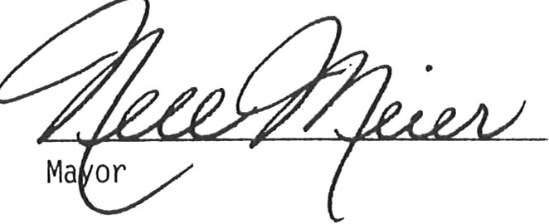ATTEST

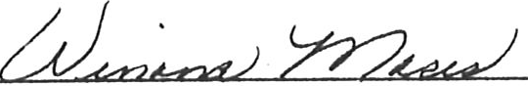

City Secretary

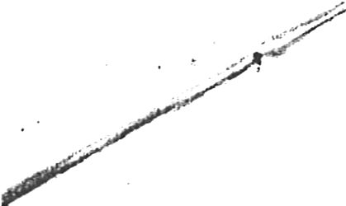

AMENDMENT TO ORDINANCE# 31

GARBAGE ORDINANCE :

SECTION 14. There shall be charged, assessed and collected from each pers011 within the city limits a monthly service charge for the pick-up of household garbage, refuse, trash and rubbish collection. All accounts that are not paid

by the final due date, as shown in the statement shall have the garbage/tr sh pick-up suspended and water service disconnected.

All other sections of this ordinance shall remain intact. Dated this the */3*,,,(,t.sJay of 7/4'/ , 1986.

ATTEST

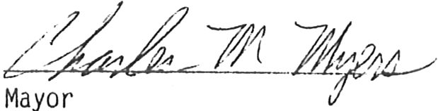*CJ. ,,*

*frt 2*

City Secretar